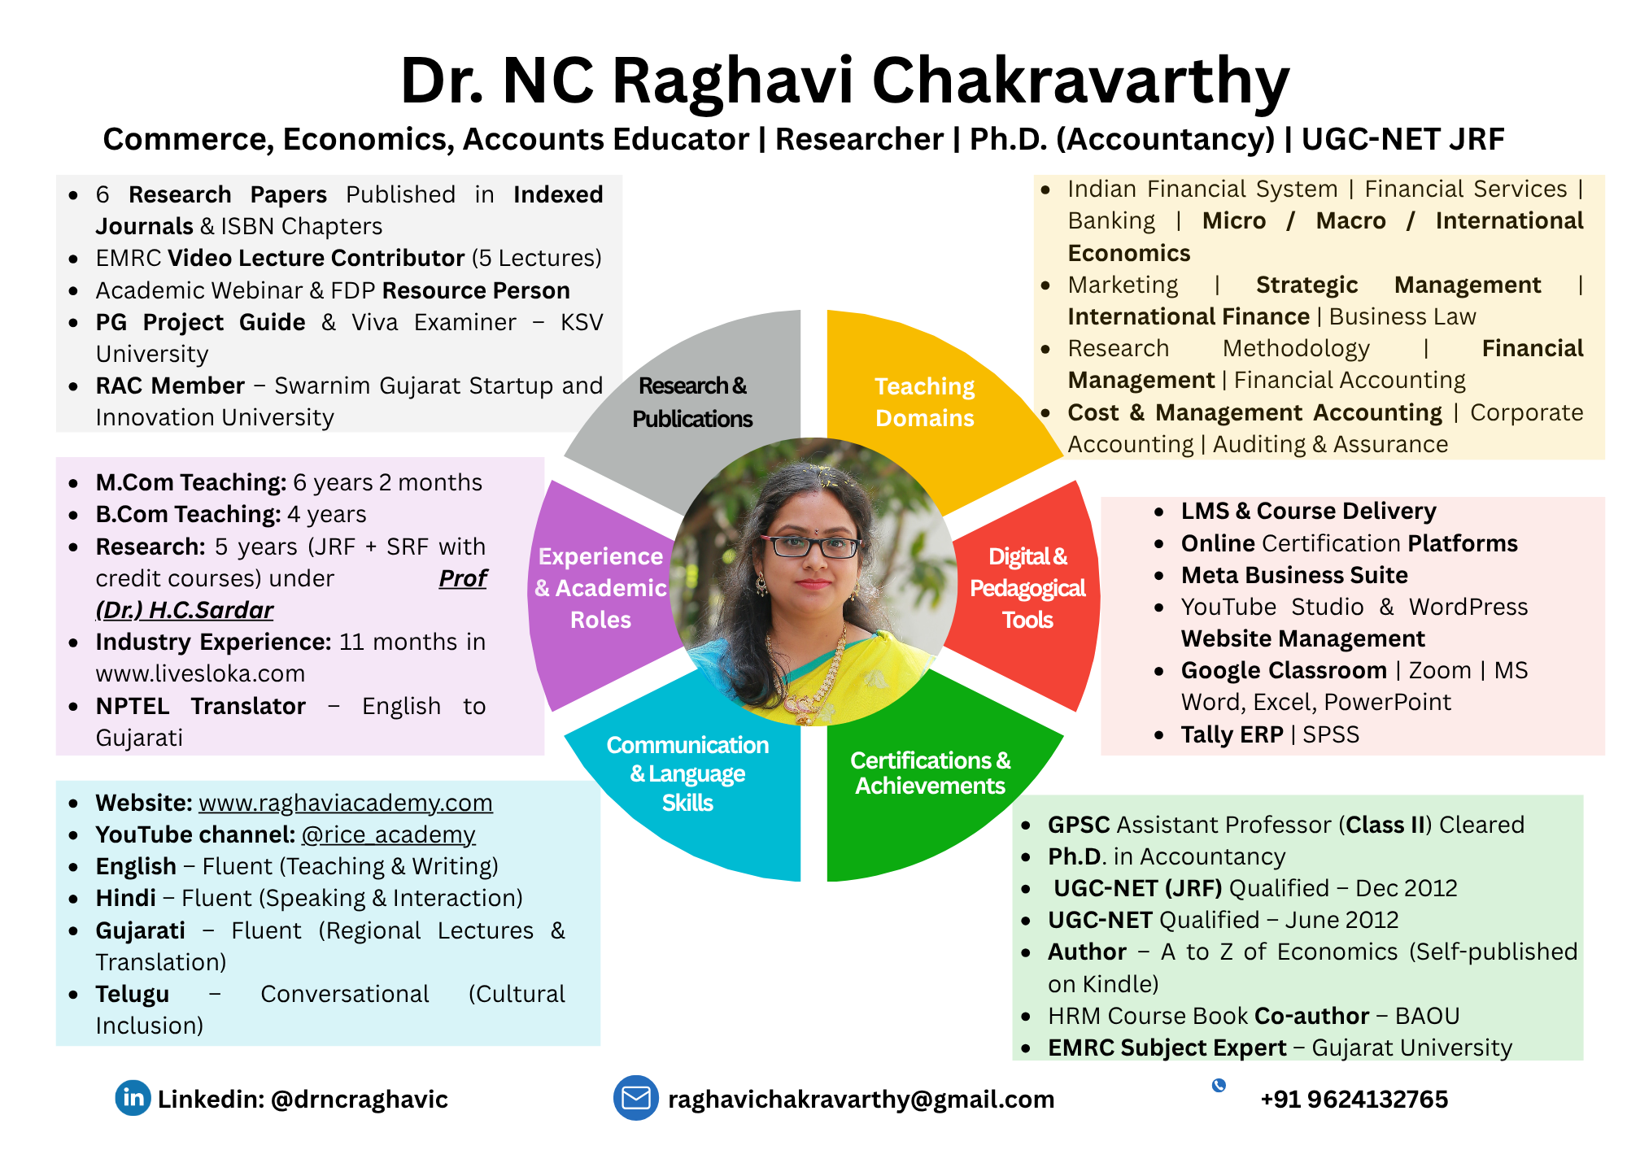
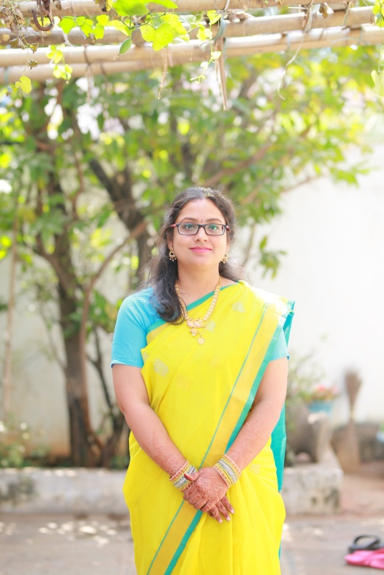

Work Experience
PG Level: 6 Years
UG Level: 8 Years
Research: 5 years
(JRF+SRF)
Industry: 11 months

Dr. NC RAGHAVI CHAKRAVARTHY
Assistant Professor (GES –II)
Ph.D. (Accountancy), UGC NET (JRF), M.Com

(E): raghavichakravarthy@gmail.com | (M): +91 9624132765

About Me

Ph.D. in Accountancy and UGC-NET JRF qualified educator with over 14 years of multi-modal experience across Government (GES-II), Autonomous, and EdTech sectors. Specialized in bridging traditional commerce pedagogy with digital innovation and entrepreneurial mentorship, having successfully launched and led multiple Startup Bootcamps and specialized certificate courses in Finance and Entrepreneurship.


Education

Doctor of Philosophy  Accountancy (Commerce)  Title of the Thesis: | May 2019  Sheth Damodardas School of Commerce, Gujarat University, Ahmedabad, Gujarat.  Implications of Household Savings on Investment Behaviour – A Study of North Gujarat Region
UGC – NET with JRF | December 2012
UGC – NET | June 2012
Masters of Commerce  Specialization in Accountancy and Finance | May 2012  Distinction  Kadi Sarva Vishwavidhyalaya, Gandhinagar, Gujarat
Bachelor of Commerce  Specialization in Accountancy and Finance | May 2010  First Class  Kadi Sarva Vishwavidhyalaya, Gandhinagar, Gujarat

Work Experience

- Subject Matter Expert (Business and Accounting) – Journal of Visualized Experiments (JoVE) from October, 2025 to March, 2026.
  - Developed and reviewed 18 technical scripts and 31 animatic reviews for global university-level Accounting and Business modules
  - Ensured 100% technical accuracy and pedagogical alignment for complex financial concepts in a digital-first format.
- Assistant Professor (GES –II), Government Commerce and Science College, Dahej from November, 2024 to September, 2025.
  - Head of Commerce Department: Led departmental planning, faculty coordination, and academic auditing.
  - Member, IQAC: Actively contributed to internal quality assurance, documentation, and accreditation processes.
  - NSS Programme Officer: Managed community outreach programs and led student volunteer initiatives for social impact.
  - Anti-Suicide Prevention Committee Member: Provided critical student support and mental health advocacy within the campus.
  - Financial Literacy Advocate: Developed and conducted a Certificate Course on Basics of Personal Finance, equipping students with essential life skills in money management and investment.
- Assistant Professor at St. Xavier’s College (Autonomus), Ahmedabad, Gujarat from July, 2021 to October 2024.
  - Departmental Coordinator (Research & Cultural): Directed student research initiatives and coordinated cultural events, bridging academic rigor with student engagement.
  - Startup Ecosystem Builder: Conceptualized and organized Startup Bootcamp 1.0 and 2.0, fostering an entrepreneurial mind-set among commerce students.
  - Course Expert: Designed and conducted a specialized Certificate Course on Start-ups, providing students with practical frameworks for launching ventures.
- Accounts Head, LiveSloka.com, from June 2020 to May 2021.
- Visiting Faculty in Masters of Commerce (HPP), in Sheth Damodardas School of Commerce from July 2018 to December 2019.
- Worked as Senior Research Fellow in Sheth Damodardas School of Commerce from December 2015 to December 2018.
- Worked as Junior Research Fellow in Sheth Damodardas School of Commerce from December 2013 to December 2015.
- Visiting Faculty in Bachelors of Commerce (B.Com.- MBA Integrated Program) from February 2014 to May 2016.
- Visiting Faculty in M.Sc. in Climate Change Impacts Management, Department of Botany, University School of Sciences, Gujarat University.
Proficiency in teaching

- Finance
  - Indian Financial System
  - Domestic Banking
  - International Banking
  - Financial markets (Money Market, Capital Market, Debt Market, Government Securities Market, Carbon trading and International Markets)
  - Financial Services: Insurance, Mutual Funds and other allied services
  - Business Law
- Business Procedures
  - Business environment
  - International Business Procedures
  - Exim and Logistics Management
- Management and Allied Areas
  - Business Organization
  - Marketing and Marketing Research
  - International Marketing
  - Strategic Management
  - Research Methodology
- Accountancy
- Elements and Basics of Accountancy
- Financial Accounting
- Cost and Management Accounting
- International Accounting
- Accounting Standards (IFRS, IndAS and other standards)
- New emerging areas – Environmental accounting, inflation accounting and other such areas
- Economics
  - Micro Economics
  - Macro Economics
  - International Economics
Languages

Language | Read | Write | Speak
English
Hindi
Gujarati
Telugu

Other Assignments

- Cleared GPSC Assistant Professor – Class II exam in Commerce.
- Member, IQAC, Government Commerce and Science College, Dahej.
- Served as a key member of various administrative committees at Government Commerce and Science College, Dahej, including Discipline, Admission, and Student Welfare.
- Has worked as a Co-author for the course book on Human Resource Management for Dr. Baba Saheb Ambedkar Open Univesity, Gandhinagar, Gujarat.
- Authored a book titled A to Z of Economics: An Encyclopedic Dictionary (Kindle version - Self Publication)
- Working as a translator for NPTEL Courses from English to Gujarati.
- External Examiner for Research Project Viva for Bachelor and Master of Commerce Students in KSV University, Gandhinagar.
- RAC Member, Swarnim Gujarat Start-up and Innovation University, Gandhinagar.
- Conducted a Certificate Couse on Basics of Financial Planning (30 Hours), in Government Commerce and Science College, Dahej for First year B.Com Students in March 2025.
- Have worked as a Subject Expert for Electronic and Multimedia Research Centre, Gujarat University in developing 5 video lectures for Undergraduate level students
    - Information Technology Act (2 video lectures)
    - Derivatives (1 video lecture)
    - International Finance – Exchange rate regimes (2 video lectures)
- Was an active Member of the Research and Development Committee in St. Xavier’s (Autonomous) College, Ahmedabad.
- Departmental Coordinator for Cultural activities for Commerce Department in St. Xavier’s (Autonomous) College, Ahmedabad.
- Departmental Coordinator for Research and Development Activities in Commerce Department in St. Xavier’s (Autonomous) College, Ahmedabad.
- Resource Person in online webinar titled, “Success is not a milestone, it is a journey” – Research leading to Publications, organized by St. Xavier’s (Autonomous) College, Ahmedabad.
- Resource Person for Certificate Couse on Launching a Successful Start-up: A Practical Course for Entrepreneurs in St. Xavier’s (Autonomous) College, Ahmedabad.
- Expert lecture in Startup Bootcamp 1.0 organized by Department of Commerce, St. Xavier’s (Autonomous) College, Ahmedabad.
- Has authored 6 research papers which have been published in reputed journals and various books in India.
  - Sharma, P. Chakravarthy N.C.R. (2020). Knock Of Advertisement In Digital Social Interaction: Informative Or Intrusion For Social Media Users. International Journal of Scientific & Technology Research Volume 9, Issue 02 , February 2020
  - Chakravarthy, N. C. R. (2018). An Analysis of the Saving Motives of the Households in North Gujarat. International Journal of Research in Computer Application & Management, Volume, (8), 9-14.
  - Chakravarthy, N. C. R. (2017). Influence of Various Aspects On The Choice Of Investment Instruments By The Households. Clear International Journal Of Research In Commerce & Management, 8(9).
  - Chakravarthy, N. C. R. (2017). A Study on the extent of financial inclusion in the North Gujarat Region. Management and Research Practices in Emerging Markets.
  - Chakravarthy, N. C. R. (2016). A Study on attempts made by selected Indian IT Companies for protection and conservation of environment. M.P. Arts and M.H. Commerce College for Women. ISBN 978-81-928180-1-6. pp. 273-285.
  - Chakravarthy, N. C. R. (2016). ICT and E Governance: A step towards Good Governance. Current Issues & Future Challenges in Business. Gujarat Commerce College, Ahmedabad. ISBN 978-81-929330-2-3 pp. 99-113.


References

- Dr. Harpalsingh C. Sardar, Retired Professor, Sheth Damodardas School of Commerce, Gujarat University, Ahmedabad, Gujarat – 380009
(Mobile): +91 9427358017
(Email): sardarhc@gmail.com
- Dr. Shankar S Sodha, Professor, Sheth Damodardas School of Commerce, Gujarat University, Ahmedabad, Gujarat – 380009
(M): +91 79908 38127
(O): 079 27912970
(E): shankarssodha@gujaratuniversity.edu.in

